Neonatal Endotyping of Childhood Asthma.
Clinical Follow-Up During 18 Years
Authors: Rikke Bjersand Sunde, MD^{1,2}; Jonathan Thorsen, MD, PhD¹; Ann-Marie Malby Schoos, MD, PhD^{1,2}; Jakob Stokholm, MD, PhD^{1,2,3}; Klaus Bønnelykke, MD, PhD¹; Bo Chawes, MD, PhD, DMSc¹; Hans Bisgaard, MD, DMSc¹
Affiliations:
1) COPSAC, Copenhagen Prospective Studies on Asthma in Childhood, Herlev and Gentofte Hospital, University of Copenhagen, Copenhagen, Denmark
2) Department of Pediatrics, Naestved Hospital, Naestved, Denmark.
3) Section of Microbiology and Fermentation, Department of Food Science, University of Copenhagen, Frederiksberg C, Denmark

ABSTRACT
Background
We previously showed an association between neonatal bacterial airway colonization and increased risk of asthma in the first 5 years of life, suggesting an airway bacteria colonization-associated childhood asthma endotype (1). Here, we have studied the long-term trajectory of such endotype.
Methods
We investigated association between airway colonization with S. pneumoniae, H. influenzae, and/or M. catarrhalis in one-month-old neonates from the Copenhagen Prospective Studies on Asthma in Childhood (COPSAC₂₀₀₀) mother-child cohort of mothers with an asthma history and development of asthma. The diagnoses were made by the COPSAC physicians longitudinally until age 18 years. Analyses were done with repeated measurement generalized estimating equations (GEE).
Results
Neonatal airway colonization was present in 66 (21%) of 319 children and was associated with an overall increased risk of asthma the first 7 years of life (GEE adjusted odds ratio, 4.31 (95% CI, 1.87-9.87, p<0.001)), but not from 7 to 18 years of age (GEE adjusted odds ratio, 1.63 (95% CI, 0.86-3.10, p=0.13)) (Figure 1). Neonatal airway colonization was also associated with number of exacerbations the first 7 years of life (adjusted incidence rate ratio, 3.47 (95% CI, 1.69-7.10, 0<0.001)), but not from 7 to 18 years of age (adjusted incidence rate ratio 1.56 (95% CI, 0.18-8.02, p=0.62)). We found that in colonized children, blood eosinophils were increased from age 6 months to 12 years (GEE adjusted geometric mean ratio, 1.24 (95% CI, 1.04-1.44), p<0.01), but not at age 18 years (adjusted geometric mean rate 0.91 (95% CI 0.75-1.12), p=0.38). There were no significant associations with lung function, bronchial reactivity, fractional exhaled nitric oxide (FeNO), allergic sensitization, total immunoglobulin E in serum (sIgE), eosinophil protein X (EPX) in urine or atopic dermatitis.
Figure 1. Risk of asthma from 0-18 years of age stratified by neonatal airway colonization with S. pneumoniae, M. catarrhalis, and/or H. influenzae, showing that the endotype associated with colonization peaked around 7 years of life and declined thereafter up to 18 years, by generalized estimating equations (colored lines) with corresponding 95% confidence area (grey ribbons).
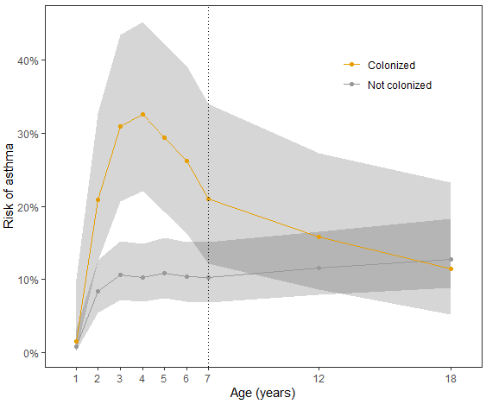
Conclusions
Neonatal airway colonization is associated with a particular endotype characterized by early-onset asthma, exacerbations, and elevated blood eosinophils, which is most prominent in early childhood, thereafter diminishing, and is no longer evident by age 18 years.

REFERENCES
1. Bisgaard H, Hermansen MN, Buchvald F, Loland L, Halkjaer LB, Bønnelykke K, et al. Childhood Asthma after Bacterial Colonization of the Airway in Neonates. N Engl J Med. 2007 Oct 11;357(15):1487–95.

